**Set D (CA 1) BASIC ELECTRICAL AND ELECTRONICS ENGINEERING (ECE 131)**

**NOTE: Attempt ALL Questions Max Marks: 30 (Each Question carries 5 Marks)**

|  |  |
| --- | --- |
| Name: | Section: |
| Reg. No.: | Roll No.: |
| Date of Test: |  |

*Believe you can and you are halfway there.*

1. Find $V_{AB}$ in the given network:

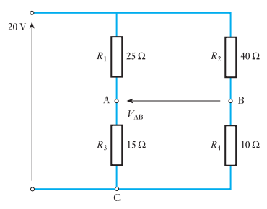

1. Find $V_{1}and V_{2}$ in the circuit using **Nodal Analysis**. Also find the current across 8 ohm resistor:

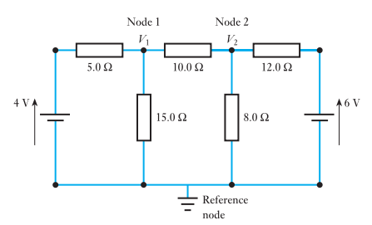

1. Find $v_{0}$ using **Superposition** in the circuit:

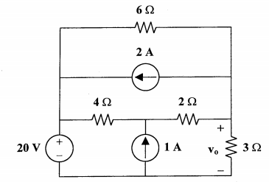

1. Find **Norton equivalent** circuit across a and b terminals in the given circuit?

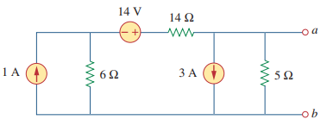

1. A series circuit with a resistor of 100 Ω capacitor of 25 μF and inductance of 0.15 H is connected across 220-V, 60-Hz supply. Calculate (i) current (ii) power and (iii) power factor in the circuit.
2. Find $i$ in the circuit when the source voltage Vs = 50 cos 200t volts.

